**Project Report**

Objective

The objective of the project is to create a program that reads and displays the data of 5 students with the help of structures, arrays and pointers.

Problem Definition

The program must allow the users to enter the name and marks of the first 5 students in order of their roll no. and then proceed to display the entered data. The program must consist of the use of structures, arrays and pointers.

Algorithm

Step 1: Firstly, the structure of the code has been defined.

Step 2: The data types of the variables firstName, roll and marks are defined.

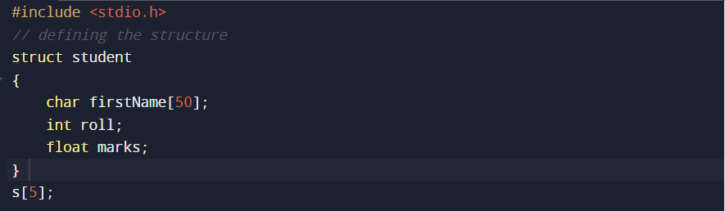

Step 3: The integer variable i, which is used as in the For loop is defined.

Step 4: Print statement requesting the user to enter the student data

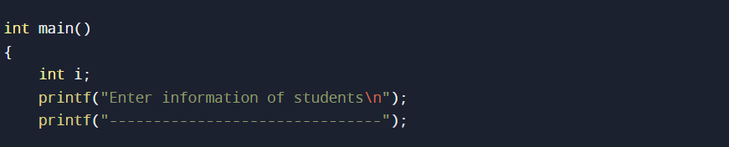

Step 5: Then the data of the students is inputted. The for loop is made to run for 5 iterations as the data is to be entered for the first 5 Roll No.

Step 6: The entered data is stored by accessing the structure variables with the help of the (.) operator.

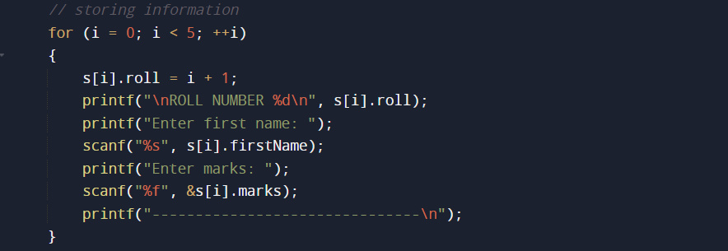

Step 7: The entered data is then displayed to the user in the order of the Roll No. of the students.

Step 8: The Roll No., First Name and the marks obtained by the students are outputted.

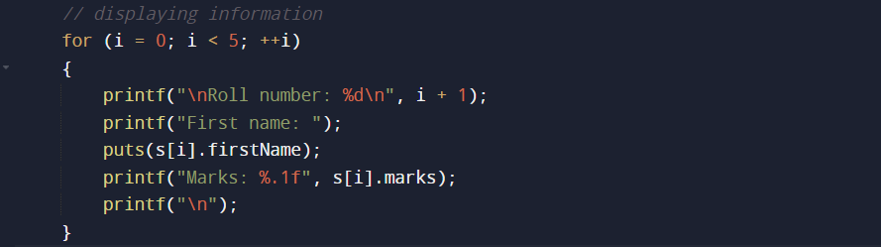

Step 9: End

Source Code

**#include <stdio.h>**

**// defining the structure**

**struct student**

**{**

**char firstName[50];**

**int roll;**

**float marks;**

**}**

**s[5];**

**int main()**

**{**

**int i;**

**printf("Enter information of students\n");**

**printf("-------------------------------");**

**// storing information**

**for (i = 0; i < 5; ++i)**

**{**

**s[i].roll = i + 1;**

**printf("\nROLL NUMBER %d\n", s[i].roll);**

**printf("Enter first name: ");**

**scanf("%s", s[i].firstName);**

**printf("Enter marks: ");**

**scanf("%f", &s[i].marks);**

**printf("-------------------------------\n");**

**}**

**printf("Displaying Information:\n\n");**

**// displaying information**

**for (i = 0; i < 5; ++i)**

**{**

**printf("\nRoll number: %d\n", i + 1);**

**printf("First name: ");**

**puts(s[i].firstName);**

**printf("Marks: %.1f", s[i].marks);**

**printf("\n");**

**}**

**return 0;**

**}**

Program

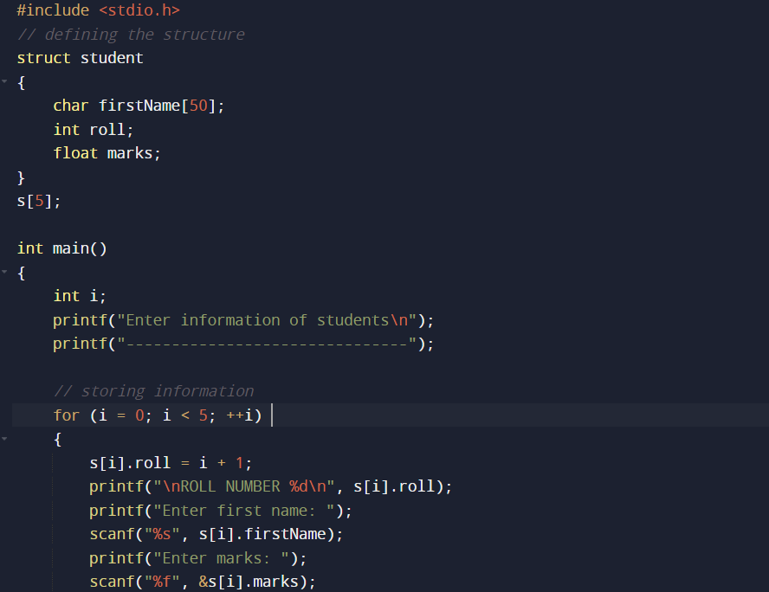

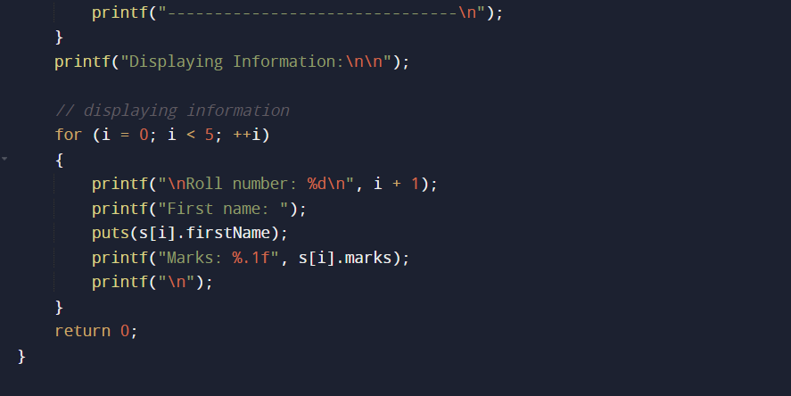

Output

